Countries That Do Not Use the Metric System
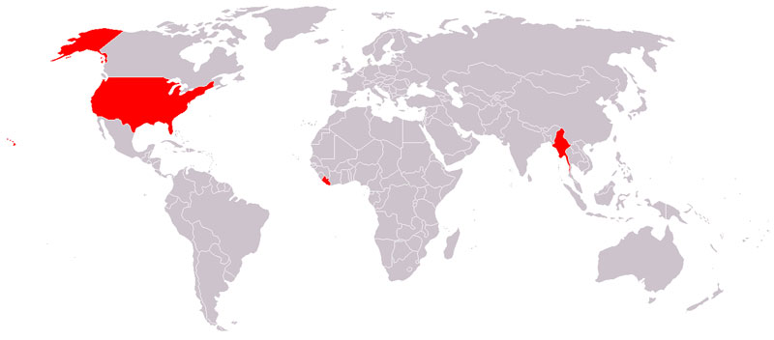

Map via Wikimedia Commons

